Alexandre Dufresne-Nappert

20948586

1. Since we are simulating a cylinder, and there are only differences in the radial direction, we can solve the problem in a 2D Axis Symmetric method.
2. Geometry Creation:

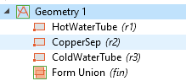

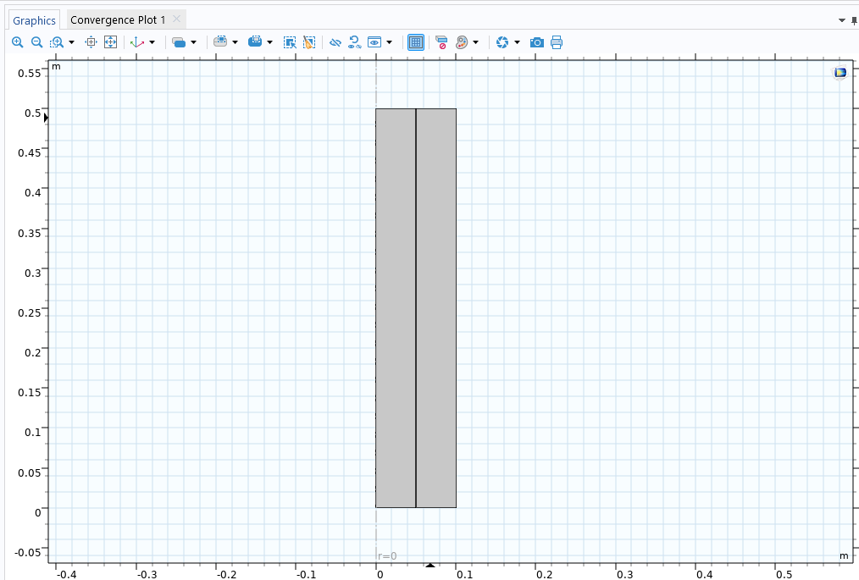

1. Generating the Mesh

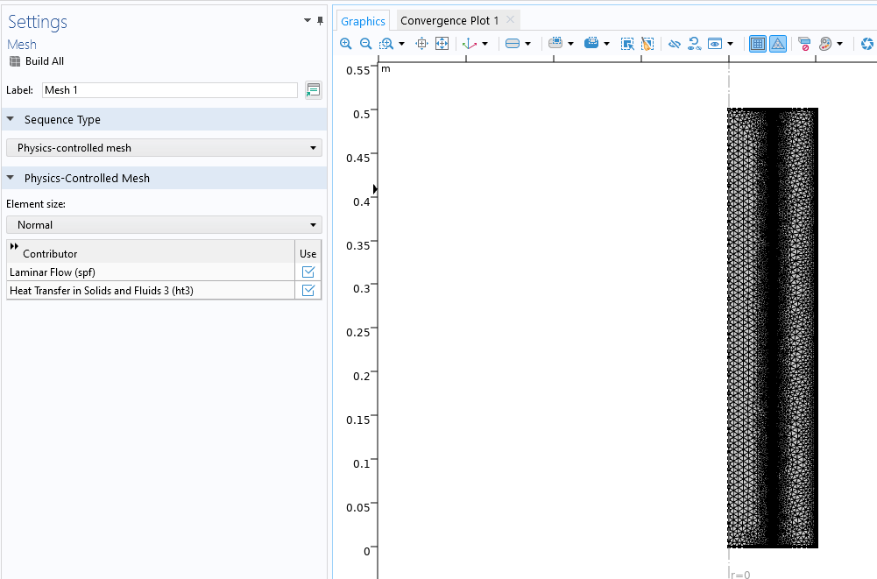

1. Apply Boundaries and Everything

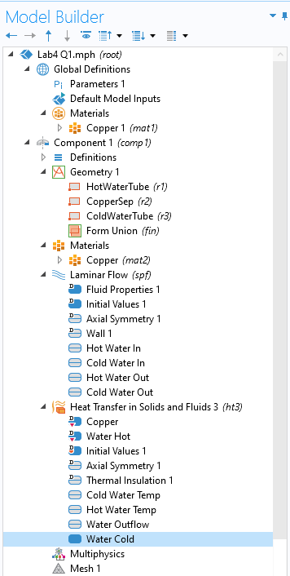

1. Inner Tube Reynolds Number

Re, Hot = $\frac{ρ×uhot,in×D}{µ}= \frac{998×0.02×0.1}{0.001}=1996\frac{kg}{m*Pa}$

Re, Hot = $\frac{ρ×ucold,in×D}{µ}= \frac{998×0.01×0.1}{0.001}=998\frac{kg}{m*Pa}$

1. Run the Simulations Co-Current

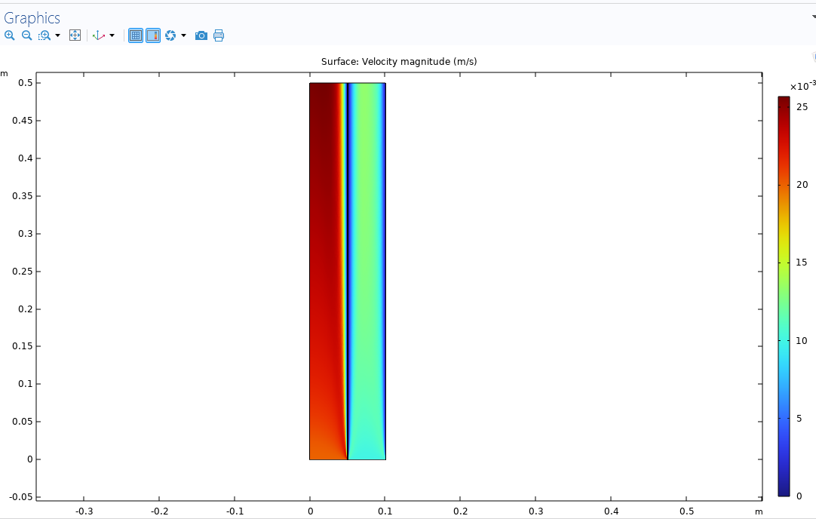

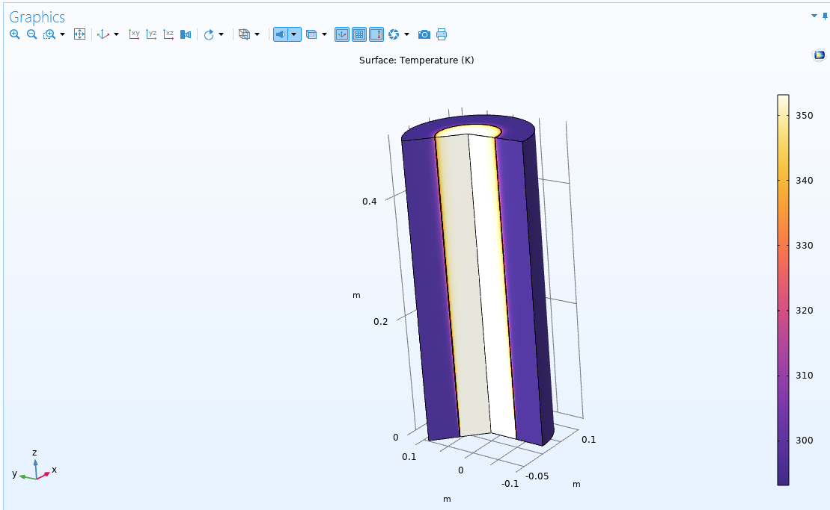

1. Results Co Current

* Velocity Profiles

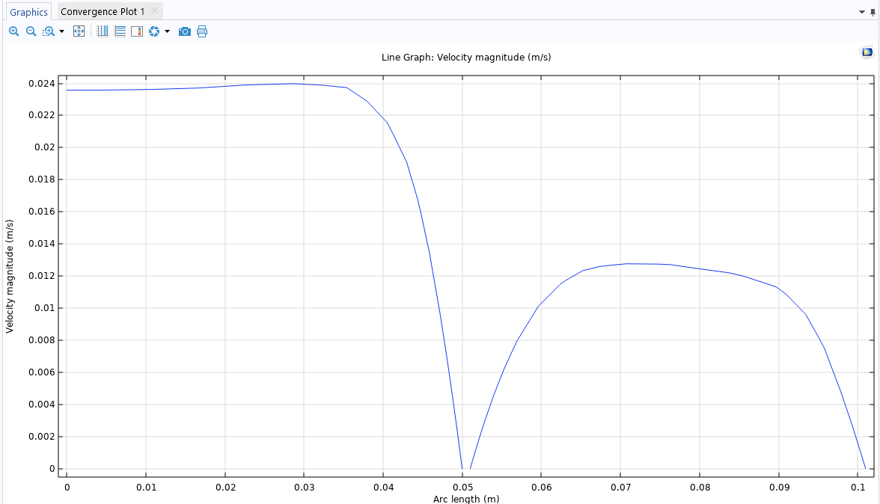

* Temperature Profile

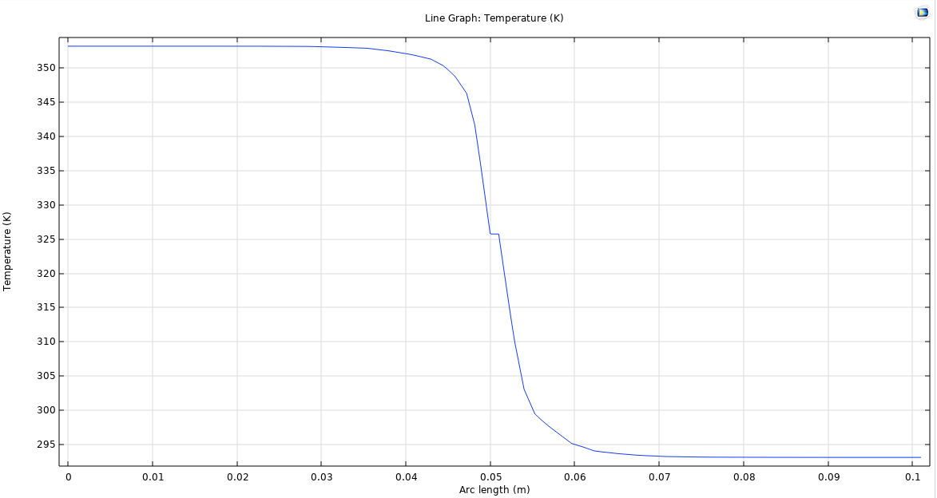

Hot Water Avg Temperature = 349.61 Kelvin

Cold Water Avg Temperature = 295.01 Kelvin

6. Counter Current Results

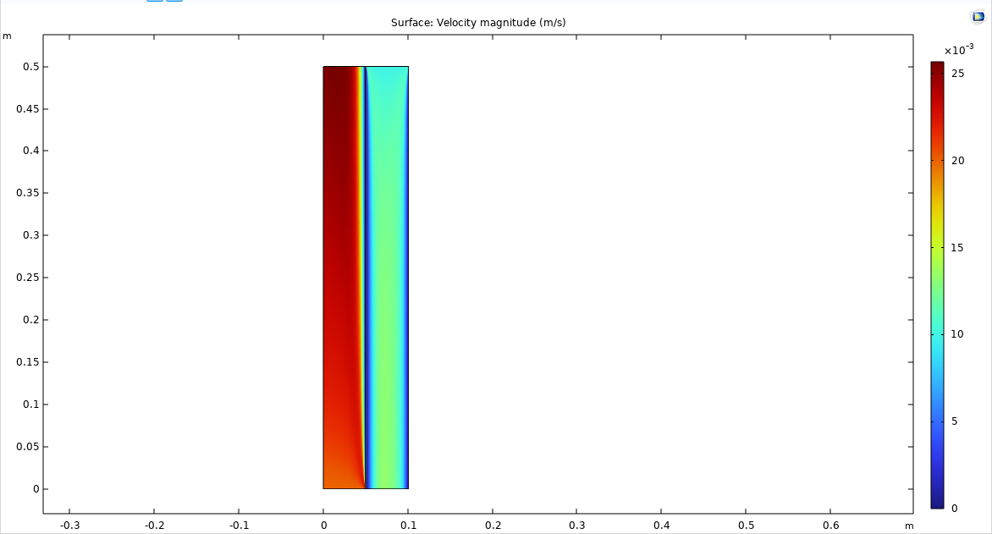

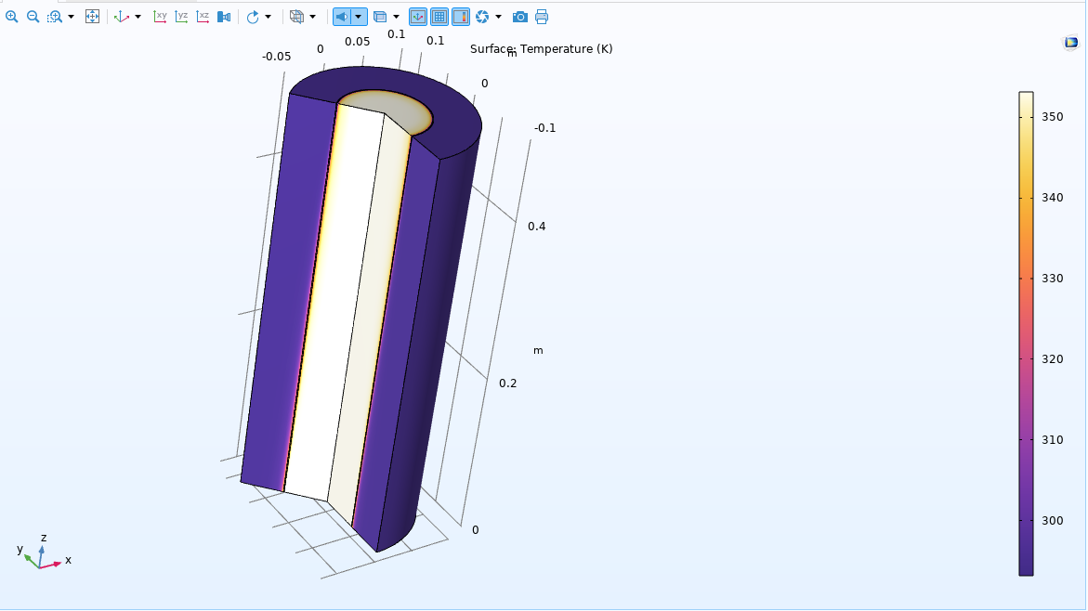

Velocity Profile

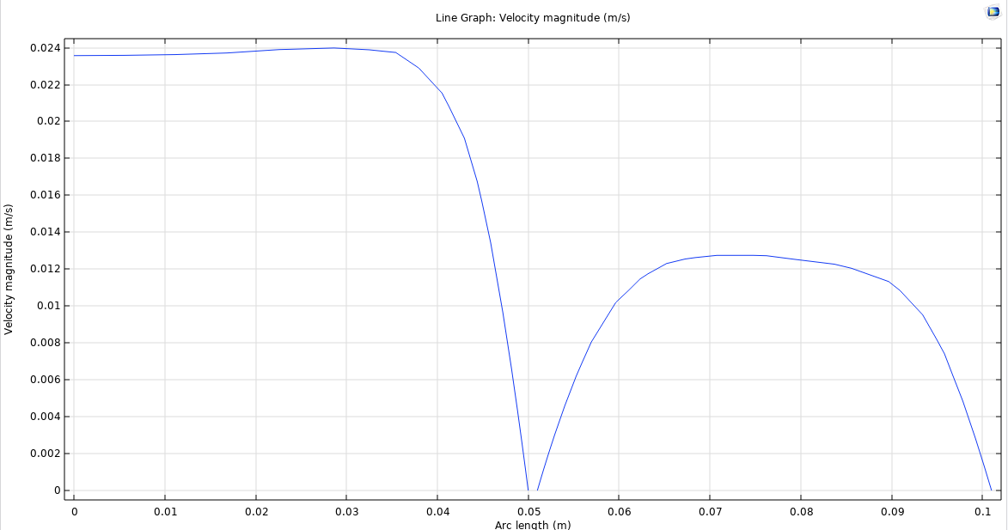

Temperature Profile

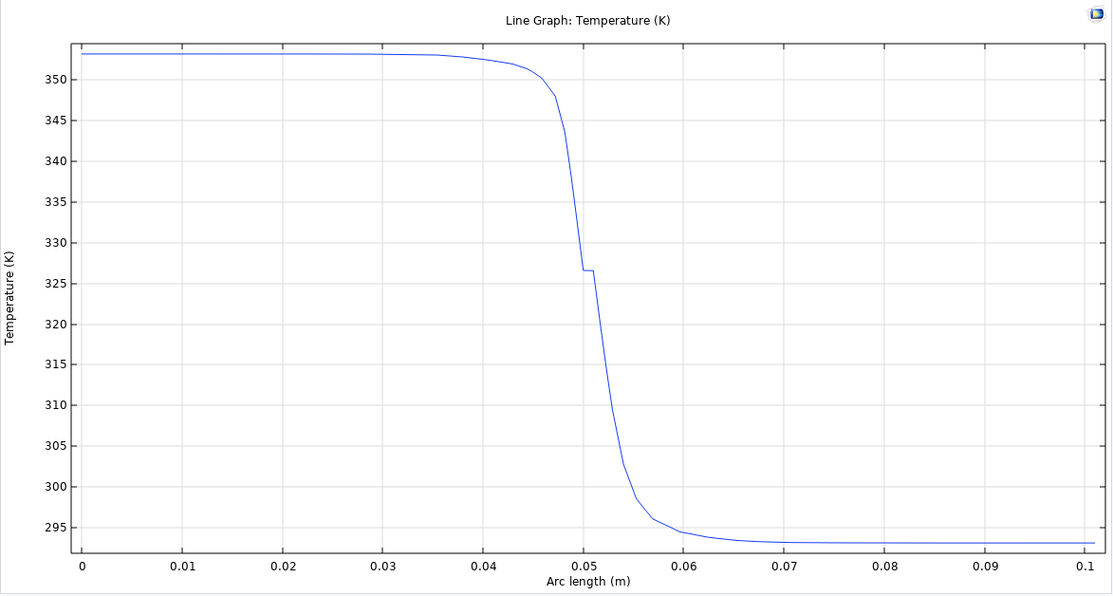

Hot Water Avg Temperature = 348.45 Kelvin

Cold Water Avg Temperature = 295.49 Kelvin

1. Comparison

For the Co-Current setup, we have the Inlet boundary conditions on the same sides at z = 0 and their outlet boundary conditions at z = Length. Then the Outflow Heat boundary conditions are also both at z = Length.

Now for the Counter Current, on the cold side, I switched the Inlet condition to z = Length, the outlet to z = 0, and the outflow at z = 0.

The temperature profiles for both configurations are not very different, from a visible standpoint, they look nearly identical, if there was an easy way to plot both graphs on the same plot, the difference might be more noticeable.

Based off the average Temperature at the outlets, for the counter current, the average hot water outlet has a slight drop in average temperature, while the average cold water temperature outlet is slightly higher in temperature

Therefor the temperature gap is slightly lower during counter current.

For efficient/faster heat transport to the Water, a counter flow regime would be faster